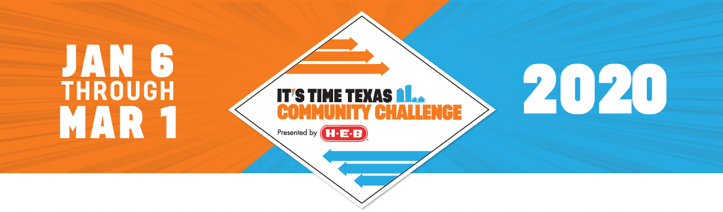
SAMPLE EMAIL FOR GENERAL OUTREACH
We know you’re already a pro at this kind of thing, but in case it’s helpful, we’ve provided an email template with a few details about the Challenge. Feel free to personalize it in whatever way you wish – or scrap it and make up your own!
Friends,
I am thrilled to share my participation in the 2020 It’s Time Texas Community Challenge. I need your help to make sure our community wins this health competition!
Taking place January 6 – March 1, the Community Challenge is a statewide competition inspiring people, organizations, and cities across Texas to choose healthy activities in support of a healthier community. You sign up on behalf of your city or school district and earn points for your community with every healthy action you submit.
At the end of the 8-week challenge, the cities and school districts with the most points in each size category get a cash prize to put toward a community health project. There are also regular prize giveaways for individual participants.
Even more than the competition, the It’s Time Texas Community Challenge is about encouraging each other to lead healthier lives and build a stronger, more connected community.
Here’s how you can get involved:
- Make the Commitment: It’s free and easy to sign up at ittcommunitychallenge.com
- Track Your Activities: Submit your healthy activities to earn points for your community and prizes for yourself
- Share the Journey: Use #CommunityChallenge to connect on social media and encourage others in our community to get involved
  - If you plan to host a community event, you can include those details here.

It’s completely free to participate and you’ll earn 500 points just by signing up. Here’s where to start: ittcommunitychallenge.com.
Come on [INSERT NAME OF CITY/TOWN], let’s commit to a healthier 2020 – and let’s win this thing.
Sincerely,

